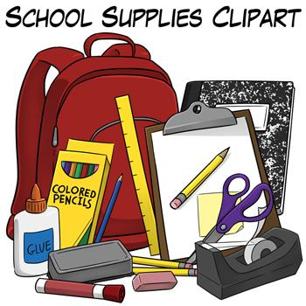
9th-12th Supplies
Miss Hackett’s classes:

    - Access to your NDCS Google Drive
    - Bible
    - English/Literature: Binder (1.5-2 inches); notebook/note paper
    - History/Government/Social Studies: Binder, (1.5-2 inches)notebook/notepaper
    - index cards (3x5 inches)
    - pencil box items: pencils, pens, highlighters, correction tape, colored pencils, markers, etc.
    - Grades 9-10 students will also require an additional binder (1.5-2 inches) for the Humanities elective

Mrs. Lazzarevich’s classes:
- Binder with paper
- Calculator
- Ruler
- Pencils

Mrs. Kessler’s classes:
- Binder with paper

Mrs. Miller’s Spanish
- Binder
- Pencils
- Highlighters
- Notecards

